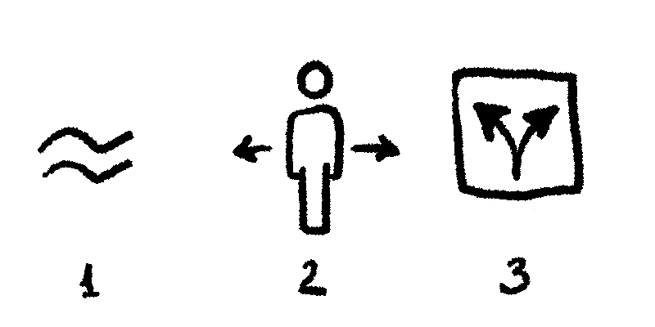

Concept for FUD

Secret group name is
Monsters and Gods

Federal bureau of immersion
Monsters and gods in logo

Eye in triangle for god
Goat horns for monsters

Or rothco outline with black and white.

